Advocacy support
- POhWER support centre can be contacted via 0300 456 2370
- Advocacy People gives advocacy support on 0330 440 9000
- Age UK on 0800 055 6112
- Local Council can give advice on local advocacy services
- Other advocates and links can be found on this PHSO webpage

Further action
If you are dissatisfied with the
outcome of your complaint from either Mid and South Essex Integrated Care System
or this organisation, then you can escalate your complaint to Parliamentary Health Service Ombudsman (PHSO) at either:
Milbank Tower, Milbank LONDON
SW1P 4QP
Citygate, Mosley Street MANCHESTER
M2 3HQ
Tel: 0345 015 4033
The

Complaints Process
Swanwood Partnership
Swanwood Partnership Market Avenue
Wickford Essex SS12 0AG
01268 56244 – swanwood.partnership@nhs.net

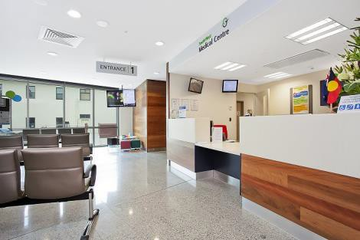

Talk to us
Every patient has the right to make a complaint about the treatment or care they have received at Swanwood Partnership
We understand that we may not always get everything right and, by telling us
about the problem you have encountered, we will be able to improve our services and patient experience.

Who to talk to
Most complaints can be resolved at a local level. Please speak to a member of staff if you have a concern and they will assist you where possible. Alternatively, ask to speak to the complaints manager, Toni Wyatt – Practice Manager, but note this may need to be a booked
appointment.
If for any reason you do not want to speak to a member of our staff, then you can request that the Integrated Care Board (ICB) investigates your complaint. They will contact us on your behalf:
NHS Mid and South Essex ICB PO Box 6483
Basildon
SS14 0UG
mseicb.enquiries@nhs.net

A complaint can be made verbally or in writing. A complaints form is available from reception. Additionally, you can complain via email to
swanwood.partnership@nhs.net

Time frames for complaints
The time constraint on bringing a complaint is 12 months from the occurrence giving rise to the complaint, or 12 months from the time you become aware of the matter about which you wish to complain.
The complaints manager will respond to within three business days to acknowledge your complaint.
We will aim to investigate and provide you with the findings as soon as we can and will provide regular updates regarding the
investigation of your complaint

Investigating complaints
We will investigate all complaints
effectively and in conjunction with extant legislation and guidance.

Confidentiality
We will ensure that all complaints are investigated with the utmost
confidentiality and that any documents are held separately from the patient’s healthcare record.

Third party complaints
We allow third parties to make a complaint on behalf of a patient. The
patient must provide consent for them to do so. A third-party patient complaint form is available from reception.

Final response
We will issue a final formal response to all complainants which will provide full
details and the outcome of the complaint. We will liaise with you about the progress of any complaint.

